# 2 User stories and Project objectives

To design and provide movie lovers with a user-friendly platform, we must first think about user stories. With user stories, we can identify this system's specific requirements and project objectives. Based on the user stories and project objectives, we conclude 9 functionalities of this system (including 2 novelties).

## 2.1 Search

User stories:

* As a movie lover, I want to search for a movie by typing a few words of its name so that I can search for the movie without knowing or typing its full name.
* As a movie lover, I want to search for a movie by typing a few words of its description so that I can search for the movie without knowing or typing its name.
* As a movie lover, I want to search for some movies by typing or selecting a genre so that I can search for those related movies.

Based on the above user stories, we know that movie lovers only want to search movies by keywords, not by the full name of the movie.

Project objective 1 can be concluded below:

Movie finders must have a user-friendly interface that allows users to search for movies based on keywords, that match the movie name, description, or genre, with listed results showing matching movie names, and their latest average rating.

Based on the user stories and the project objective, we can conclude the 1st functionality: Search.

## 2.2 Movie details

User stories:

* As a movie lover, I want to see movie details so that I can know what the movie is about and whether I am interested in it.

Based on the above user stories, we know that movie lovers want to view movie details which can help them decide whether to watch the movie.

Project objective 2 can be concluded below:

Movie finders must provide users with detailed information about each movie, including the movie name, description, genre, cast, director, latest average rating, and all associated reviews.

Based on the user stories and the project objective, we can conclude the 2nd functionality: Movie details.

## 2.3 Recommendation

User stories:

* As a movie lover, I want to find some movies that are similar to a movie I searched for so that I can watch them or add them to my wish list.

Based on the above user stories, we know that movie lovers want to be recommended some movies based on their data in the system.

Project objective 3 can be concluded below:

Movie finders must have a recommendation system that suggests movies similar to those the user like.

Based on the user stories and the project objective, we can conclude the 3rd functionality: Recommendation.

## 2.4 Wish list

User stories:

* As a movie lover, I want to add a movie to my wish list so that I can watch them later.
* As a movie lover, I would like to remove a movie from my wish because I change my mind.
* As a movie lover, I want to see other people’s wish lists so that I can see what they are interested in.

Based on the above user stories, we know that movie lovers want to manage their wish list.

Project objective 4 can be concluded below:

Movie finders must be able to allow users to create and manage their wish lists, including adding or removing movies.

Based on the user stories and the project objective, we can conclude the 4th functionality: Wish list.

## 2.5 Review and rating

User stories:

* As a movie lover, I would like to leave reviews for movies I watched.
* As a movie lover, I would like to rate a movie I watched.

Based on the above user stories, we know that movie lovers want to comment on movies they watched and rate them.

Project objective 5 can be concluded below:

Movie finders must provide a review and rating system that allows users to rate and leave reviews for movies they have watched.

Based on the user stories and the project objective, we can conclude the 5th functionality: Review and rating.

## 2.6 Browse

User stories:

* As a movie lover, I want to browse movies by director so that I can know what movies the director has made.
* As a movie lover, I want to browse movies by genre so that I can know what movies are available under this genre.

Based on the above user stories, we know that movie lovers want to browse movies by some specific types or directors.

Project objective 6 can be concluded below:

Movie finders must enable users to browse movies by director and genre.

Based on the user stories and the project objective, we can conclude the 6th functionality: Browse.

## 2.7 Banned list

User stories:

* As a movie lover, I want to add some reviewers to my banned list because I do not like their review and their rate for movies.

Based on the above user stories, we know that movie lovers want to manage their banned list.

Project objective 7 can be concluded below:

Movie finders must be able to allow users to create and manage their banned lists, including adding or removing other users.

Based on the user stories and the project objective, we can conclude the 7th functionality: Banned list.

## 2.8 Novelty: News

User stories:

* As a movie lover, I want to view movie news so that I can know what is going on about movies.

Based on the above user stories, we know that movie lovers want to view some movie news.

Project objective 8 can be concluded below:

Movie finders must provide a news section for users to stay up to date on the latest movie-related news.

Based on the user stories and the project objective, we can conclude the 8th functionality: News.

## 2.9 Novelty: Discussion

User stories:

* As a movie lover, I would like to post article of any movies without limited size.
* As a movie lover, I would like to discuss with people of movies, not only leave a review.

Based on the above user stories, we know that movie lovers want to discuss with other people about movies.

Project objective 9 can be concluded below:

Movie finders must provide a platform for users to share their thoughts and opinions.

Based on the user stories and the project objective, we can conclude the 9th functionality: Discussion.

# 3 Project management

Based on the user stories and project objectives, we conclude 9 functionalities the Movie Finder System must achieve. In project management, these 9 functions can be divided into 4 epics:

Epic 1 is “Movie”, including search, movie details, recommendation, wish list, review and rating, browse, banned list.

Epic 2 is “News”, including the news functionality.

Epic 3 is “Discussion”, including the discussion functionality.

Epic 4 is “Authority”. This epic does not include any functionalities that we consider above. But we need this authority to provide users with accounts to manage their data like the wish list and the banned list.

With the information, we can set up our backlog and sprints in Jira.

## 3.1 Backlog

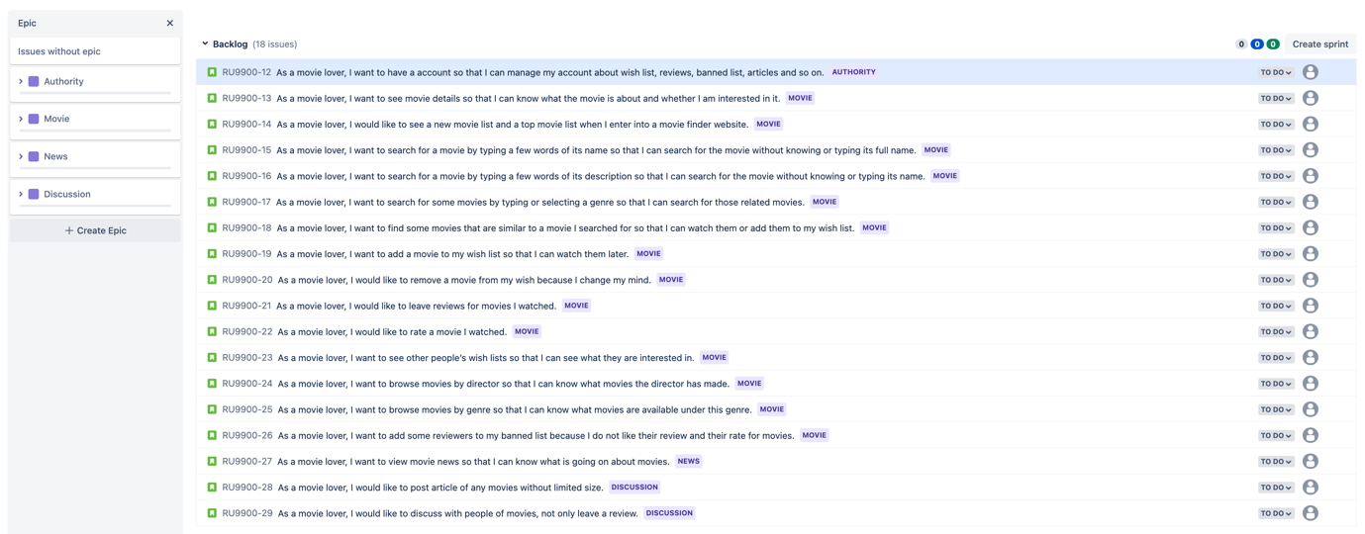

## 3.2 Sprints

Sprint schedule:

|  |  |  |
| --- | --- | --- |
| Sprints | Date | Activities |
| Sprint1 | Mar1 – Mar15 | Epic1: Authority Epic2: Movie (only finish these functionalities: search, movie details, wish list, browse, banned list)  Epic3: News |
| Sprint2 | Mar16 – Apr5 | Epic2: Movie (finish the rest functionalities of this epic: recommendation, review and rating) |
| Sprint3 | Apr6 – Apr19 | Epic4: Discussion |

Below is the first sprint screenshots in Jira.

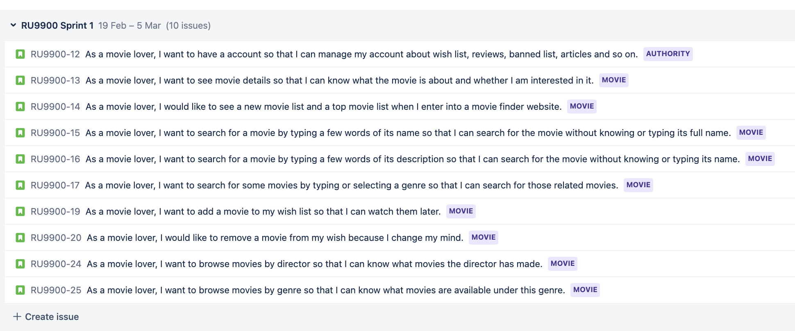

## 3.3 Roadmap

